



Empiric Grimoire: User Guide

Version Date: January 2017

**Empiric Grimoire: User Guide**

**Introduction**

The Empiric Grimoire (EG) was created to easily calculate the time needed for Empirical testing in the SPIE team. It queries Game Design’s database and determines all the strategies of any game. Then, based on our minimum best guess in the config file, it calculates the amount of time required to execute these strategies.

The duration is determined by: the number of strategies, the required spins of the strategies and the average time taken to reach 10mil spins for the particular game type e.g. Slot games will take 4 hours to reach 10mil spins.

The average time taken for each game is specified in the app’s config file which means this tool is configurable for changing environment speeds and Game Design benchmarks (i.e. the min spins is currently 10mil).

The config file also contains a list of all our current dev partners. This list can be expanded as more Dev partners join Derivco.

This doc will explain how to use the app and how to change the config file in the event of changing benchmarks.

Special thanks to Samantha Kogel for designing the new logos and interface. This makes it at least 20% cooler ;)



Table of Contents

1 Initial Setup 3

1.1 Necessary files 3

1.2 Changes to the config file 3

2 Using the GUI 4

2.1 Textbox (2) 5

2.2 Add button (3) 5

2.3 Delete button (4) 5

2.4 Query button (6) 6

2.5 Menu options (1) 7

2.5.1 Import Gamelist (1.1.1) 7

2.5.2 Save as spreadsheet (1.1.2) 7

2.5.3 Open config (1.1.3) 7

2.5.4 Clear All option (1.2) 7

2.5.6 Help button (1.3) 8

3 Editing the config file 9

3.1 Basics of a XML file 9

3.2 configSections 9

3.3 appSettings 9

3.4 Games 10

3.5 All subsequent sections 11

4 Common issues 12

# Initial Setup

The EG should run on any machine that has .NET 4.5.2 installed on it as it is a C# WPF application and requires this version of .NET. Microsoft Excel is not necessary in order to create Excel files.

## Necessary files

In order to install the application you will need the **setup.exe** found in the following location:

[<blank>](https://dersvn05/repos/IQLSPIERepo/Empirical/C%23/Empiric%20Grimoire/)

Once run on your machine it will install the following files in the following location:

C:\Program Files (x86)\Derivco\EmpiricGrimoire

* The EmpiricGrimoire.exe (The Application)
* The EmpiricGrimoire.exe.config (The config file)
* ExcelHelper.dll (A helper library I created)
* SQLHelper.dll (A helper library I created)
* A folder called “SQL Queries” which contains:
  + Query_Gamename.sql
  + Query_MinspinsandHours.sql
  + Query_LoggingDetails.sql
* A folder called “Logs” where logs will be saved
* The files necessary for creating an Excel doc[1]:
  + EPPlus.dll

**NOTE:** The folder name can be changed as long as EmpiricGrimoire.exe.config points to the correct folder. However, don’t change the names of the sql scripts. They are hard coded in the app and the queries won’t run if they are renamed.

**NOTE:** The application now checks for an intranet connection to Game Design’s database. Without this connection the application won’t open. The application also tries to connect to my logging database before logging information. If a connection can’t be made, the information to a log file.

## Changes to the config file

* If you renamed the “SQL Queries” folder you will need to go to the EmpiricGrimoire.exe.config and edit the tag:



This value can’t be left blank so your scripts will have to be contained in a folder.

* If the connection string to Game Design’s database has changed then you will need to edit “MathsDB” and/or “ConnectionString” in the EmpiricGrimoire.exe.config.
* If the minimum required spins has changed then you will need to edit “MinSpins” in the EmpiricGrimoire.exe.config.
* If the logging database has been moved you will need to edit “MachineLog” and/or “ConnectionLog”

# Using the GUI

The following section outlines the features of the app:

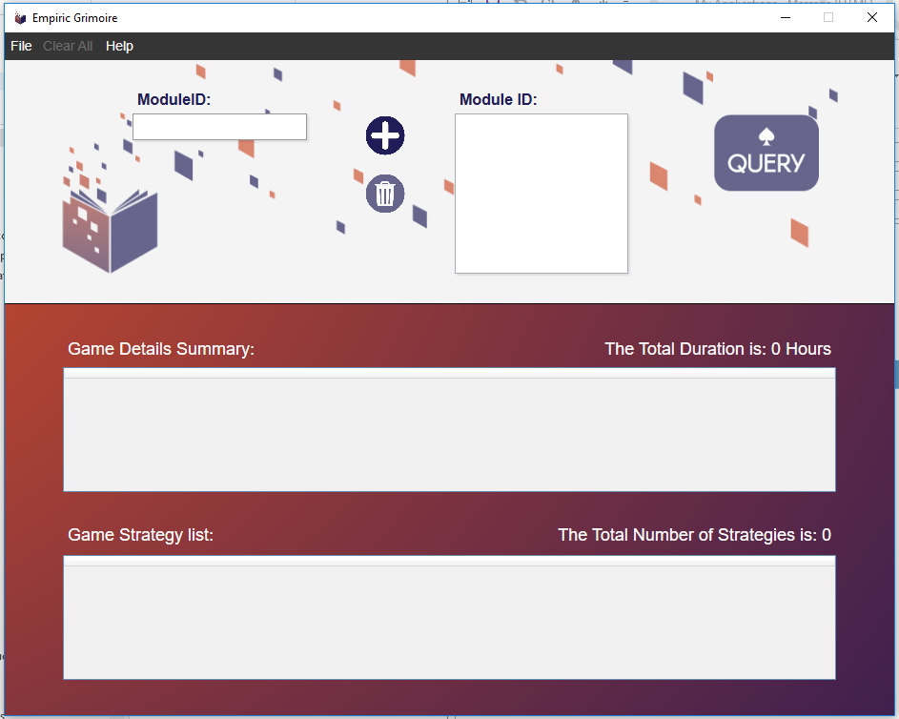

**Standard flow of EG:**

1. Input the ModuleID in the textbox (2)
2. Press the ADD button (3) to add the ModuleID to the list of games to query (or press enter)
3. The ModuleID will be displayed in the list (5)
4. Repeat until all the games to be tested are in the list.
5. If you wish to remove a ModuleID from the list:
   1. Select the ModuleID in the list (5)
   2. Click on the delete button (4)
6. Click on the Query button (6) to query the Maths Database
7. The Game Details Summary (7) and Game Strategy list (8) are then populated with the details of the game
   1. Game Details Summary (7):
      1. Game Type is based on whether the game is a e.g. Slot, Roulette, etc. This is based on the ModuleID, Module Name and the ModuleID ranges in the config file
      2. Total Hours is the sum of the durations per strategy
      3. # of Strategies is a count of all the strategies the game has
      4. Notes are shown if the game has special requirements or requires warnings
   2. Game Strategy list (8)
      1. Displays the expected percentage, Volatility Index and Standard deviation of the game.
      2. The name and file name of the strategy
      3. The required number of spins (based on the VI and current standards from Game Design)
      4. Hours required to generate the min amount of spins
8. Once data is generated you can save it by clicking on the menu option File>>Save as Spreadsheet (1.1.2)
9. The Clear All menu option (1.2) removes all data from the application
10. The help button (1.3) displays a short description of the application as well as a link to the confluence page.
11. If you wish to change the config file, we have provided the menu option File>>open config (1.1.3). This option opens the config in notepad++ (or notepad) for editing.
12. If you’d prefer to import a text file of MIDs then use the File>>Import Gamelist (1.1.1) menu option.

## Textbox (2)

This textbox should only accept positive integers. No special characters are allowed. If you try to enter a non-integer then there is an error message that will be displayed. The ModuleID won’t join the list but the textbox won’t be wiped in case you accidentally typed another character.

## Add button (3)

This button is used to add the typed ModuleID to the ModuleID list. You can also press enter while in the textbox and it will have the same effect.

The check for a non-positive integer ModuleID is performed here.

## Delete button (4)

This button allows you to remove a ModuleID from the ModuleID list. It needs to be selected in (5) otherwise an error message is displayed. If after deleting a ModuleID, the list is empty the user should be unable to query or save data.

If you press delete after selecting a ModuleID the same action will be performed.

## Query button (6)

This button queries the Game Design database for the details of all the ModuleIDs listed to be queried. If there are no ModuleIDs in the list then this button should be disabled. The results are displayed in (7) and (8).

You can add/delete ModuleIDs from the list and only once the query button is pressed will the data displayed in (7) and (8) be updated.

If you press F5 while the window or textbox is selected this action will also be performed.

## Menu options (1)

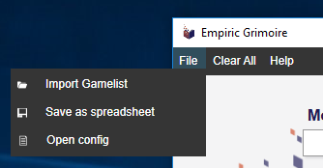

1.1.3

1.1.2

1.1.1

### Import Gamelist (1.1.1)

This menu option allows you to load a text file of ModuleIDs into the application. Each new ModuleID must be on a new line. Clicking on this option will open a window to locate the textfile. If you don’t select a file an error message will be displayed.

**Note**: If a ModuleID is not an integer or is too long, it will be ignored.

### Save as spreadsheet (1.1.2)

This menu option saves what is currently displayed in (7) and (8) to an Excel file. Once clicked a window will open to allow you to navigate to a folder location and name the Excel file.

**Note:** This application doesn’t require Microsoft Excel to be installed on the host machine in order to create the Excel doc.

### Open config (1.1.3)

This menu option allows you to easily open the application’s config file in notepad++. If notepad++ isn’t installed on the host machine it will be opened in notepad.

**Note:** Any changes to the config file won’t take effect until the application is restarted.

### Clear All option (1.2)

This button deletes all data currently being displayed. Similar state to restarting the application.

If you press F4 while the window is selected this action will also be performed.

### Help button (1.3)

This button displays a description of Empiric Grimoire. It includes a link to the online help.

If you press F1 while the window is selected this action will also be performed.

Clicking on the help window will make it disappear.

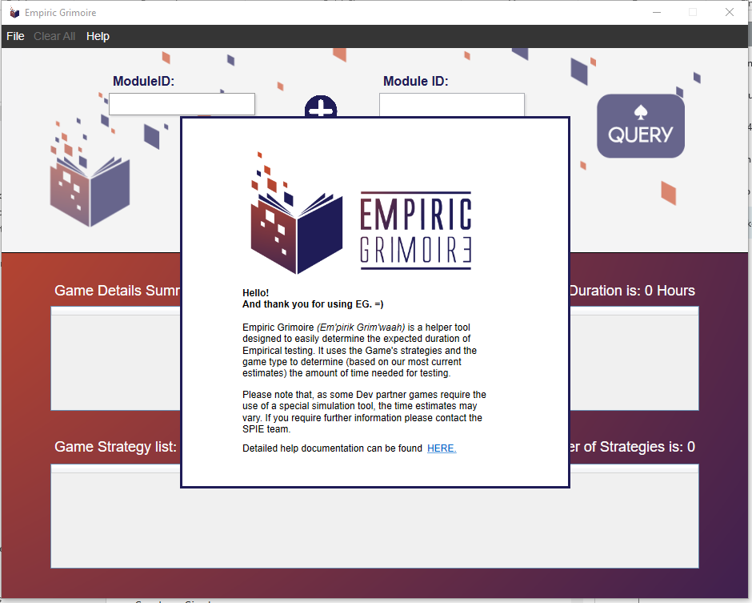

# Editing the config file

The config file (EmpiricGrimoire.exe.config) has many settings and it is unlikely you will need to add more elements. However, as standards change values may need to be edited.

This section will outline:

1. How to read an XML file (config file)
2. Using the appSettings section tag
3. Using the Games section tag
4. Using all remaining section tags

**Note:** The config file can be opened via the menu option File>>Open config.

## Basics of a XML file

Extensible Markup Language (XML) is a document structure commonly used at Derivco. All .config files contain the XML format and can be handled in exactly the same way.

The XML structures I will be referring to in the following sections are as follows:

Section tag

Key Attribute and value

Section Collection tag

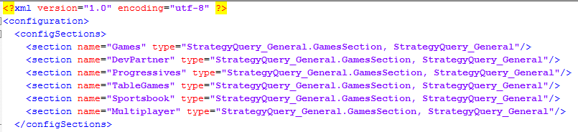

Attribute and value

Closing element tag

Opening element tag

* Section tags help group sections of elements together.
* The tag “configSections” is a special type of section tag. It contains a collection of elements which have a similar structure. In this example it is also the “opening element tag” of the collection. The collection finishes once we see the corresponding “closing element tag”.
* All the key elements have the attribute name “name” in this app’s config. Key attributes can’t be left out or set to an empty string.
* There are many examples of attribute and value pairs in this config file.

## configSections

This section contains all settings for custom sections and section collection tags. Without this section you wouldn’t be able to specify e.g. DevPartners.

This section should never need editing. Please avoid making changes as the app may not function.

## appSettings

This tag section collection should always contain the default values for:

* MathsDB – The machine where Game Design’s database is stored
* ConnectionString – The connection string to Game Design’s database containing the list of strategies per game.
* ScriptLocation – The location of the two SQL scripts used by the app to query the game name and strategies of the game.
* MinSpins – The minimum required spins per game, as per Game Design’s request.
* MachineLog – The machine where the logging database is stored
* ConnectionLog – The sql connection to my logging database.
* ApplicationName – The name of the application. Used for logging purposes only.

Neither the key attribute nor the value attribute should be left blank.

Example section:

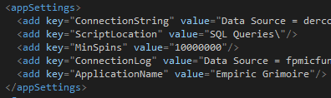

## Games

This tag section contains the average time to complete all games except Dev partner games. The app only ever needs/can handle 7 distinct values in this section:

* Slot – All standard slot games which play through PlayerSim
* FastTable – roulette, baccarat, craps, keno
* SlowTable – All other table games
* Sportsbook – Scratch cards, Sportsbooks and 1x2Gaming (e.g. darts)
* Progressive – All progressive slot games
* Multiplayer – Multiplayer table games, Tournaments, MP slots and Class II
* Default – Anything not covered

Please don’t change any of the name values, the app searches for specific ones and will crash if they aren’t present.

The mintime values can be edited however they can’t be left blank or omitted.

Example section:

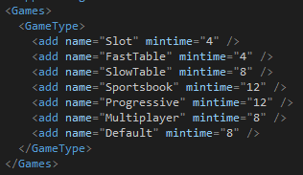

## All subsequent sections

These sections can have as many elements as you like however they should always contain the element attribute “Default” which doesn’t need the attributes minMID and maxMID.

**NOTE:** When the MID being queried is being compared to the min/max range, the min is included but the max isn’t. That is:

minMID ≤ MID < maxMID

The mintime specifies the time it will take to reach the MinSpins (10mil). The name attribute doesn’t have to be anything specific it just has to be unique and can’t be left blank.

Example section:

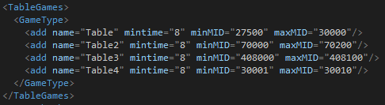

# Common issues

Outline any common issues

1. Due to the way the Application was created, Empiric Grimoire doesn’t require the hosting PC to have Microsoft Excel installed in order to save the data in an Excel file. It makes use of the EPPlus library to create the doc allowing data saving on machines that don’t have Microsoft Excel installed.